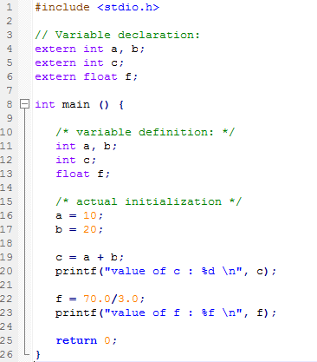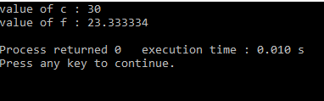

CONSTANTS AND LITERALS`

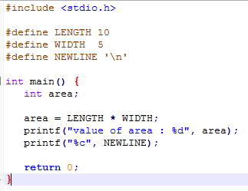

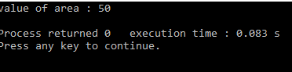

DECISION MAKING

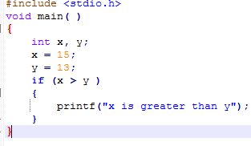

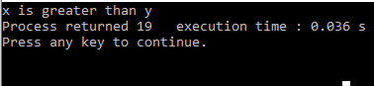

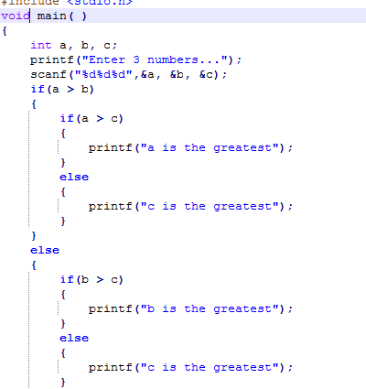

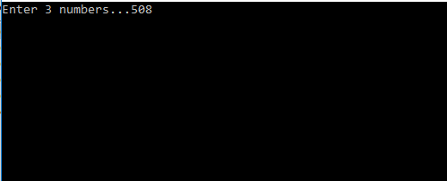

DATA TYPES

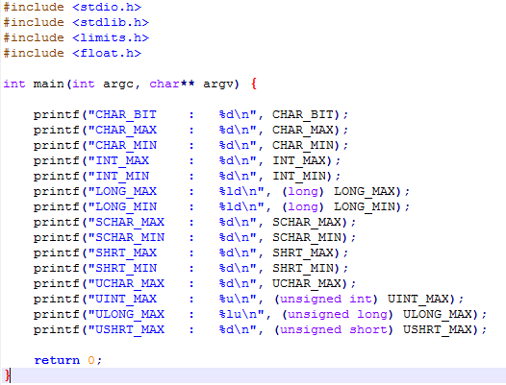

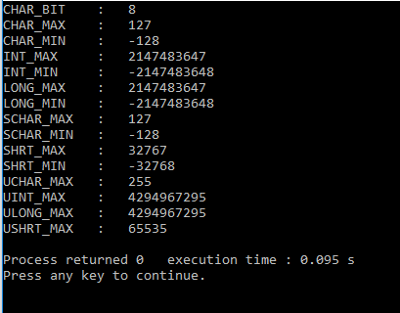

PROGRAM STRUCTURE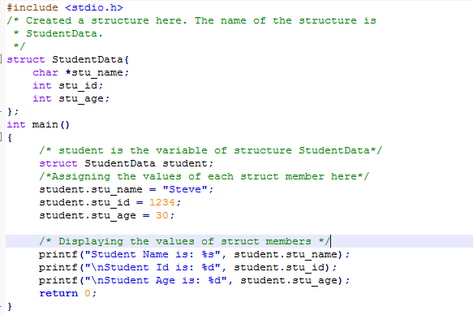

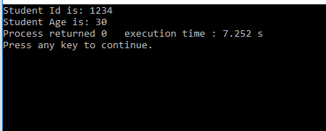

STORAGE CLASSES

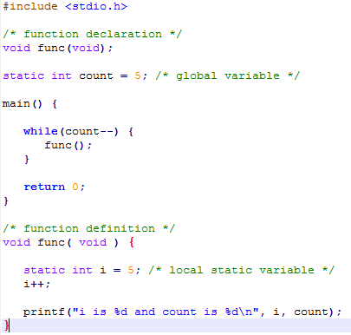

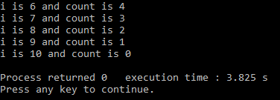

LOOPS

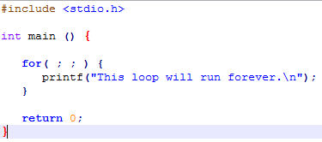

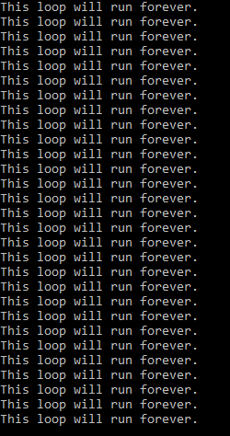

SCOPE RULES

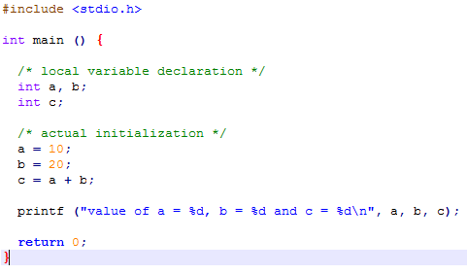

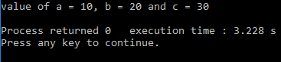

C FUNCTIONS

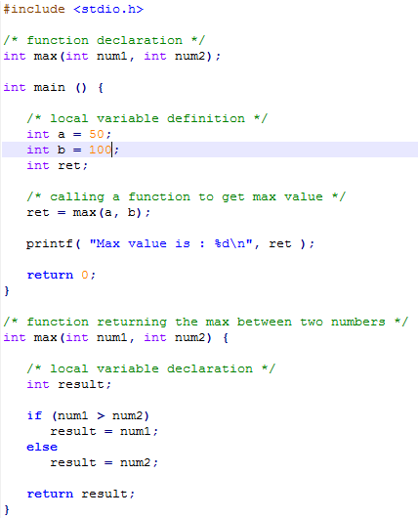

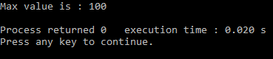

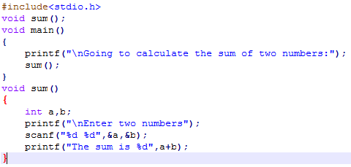



ARRAYS

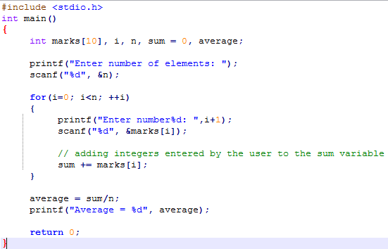



C OPERATORS

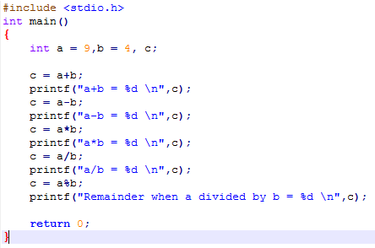

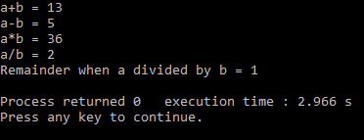

GROUP MEMBERS

BSCAS/2020/89729---JAMES MAINA

BSCAS/2020/91159---MIKA LUYAKHA

BSCAS/2020/92262---DENNIS MWENDA KINOTI

BSCAS/2020/91912---KENEDY MUGAMBI

BSCAS/2020/89710---GEOFFREY MUTUKU

BSCAS/2020/92116---ORE ADAM

BSCAS/2020/91650---MARK ANTONY

BSCAS/2020/90311---MOHAMMED ZULU

BSCAS/2021/ ---MARK NGUGI